**APC Mahalaxmi College For Women**

**-Thoothukudi**

**Department Of Mathematics(UA)**

**PROJECT REPORT TEMPLATE**

**Project Title:**

**Measuring Success in Talent**

**Management**

*Team Members:*

**P.Muthu Priya**

**S.Karthika**

**K.Ponkarthika**

**S.Megha**

**A.Rossari Subista**

**1.INTROCTION:**

* **Over view**

**In the post- pandemic world, organizations require new management approaches and evidence-based analytics. Using a more structured approach, organization will gain actionable insight into over all leadership and management effectiveness and alignment of the most appropriate talent with the most vital business outcomes.**

**. Purpose**

**A multi hospital health care system prioritized front lin management effectiveness over every other business practice that innovative approach to talent management contributed to a dramatic shift to improve outcomes by virtually measure**

**Problem Definition & Design Thinking**

**EMPATHY MAP**

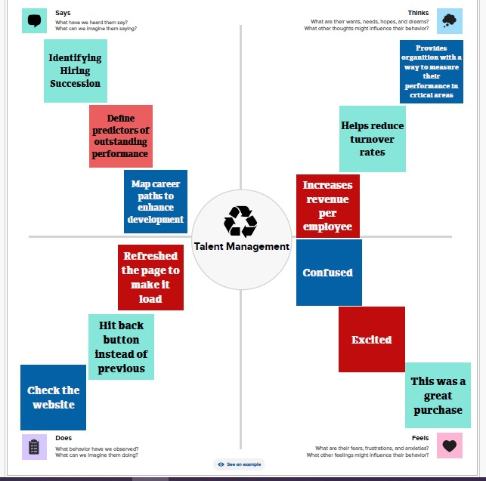

**IDEATION AND BRAINSTORMING MAP**

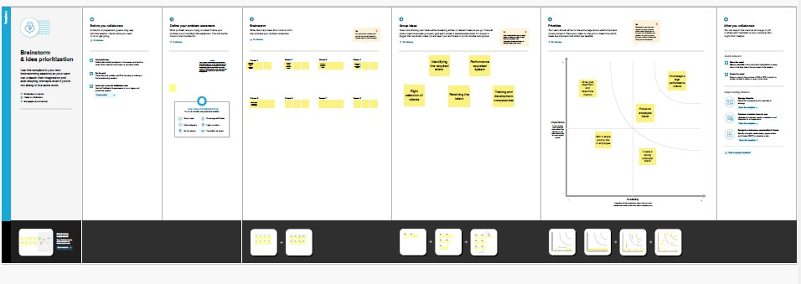

**Result:**

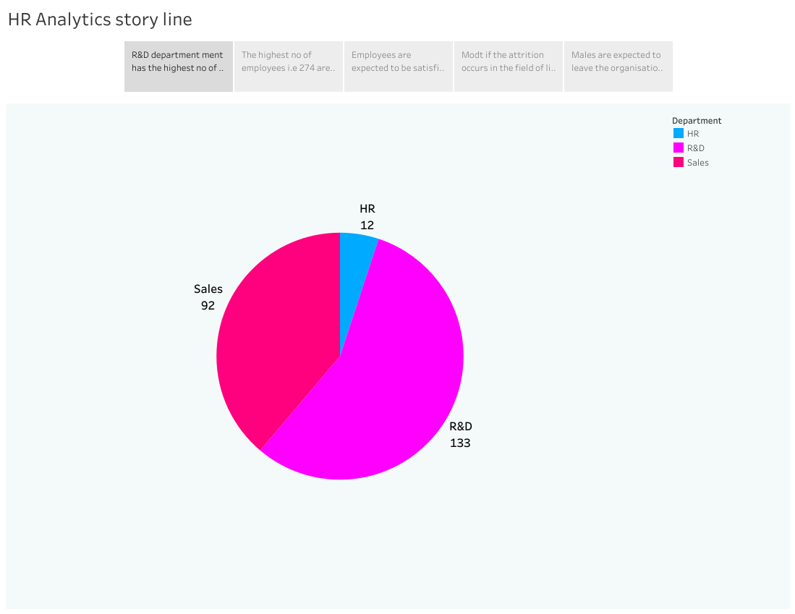

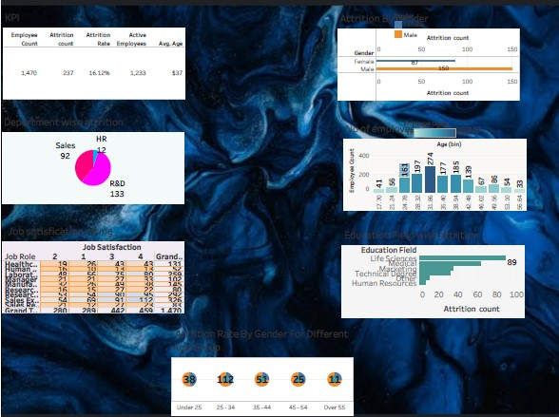

 

**Advantages & Disadvantages:**

**List of Advantages:**

* **Help in ascertaining the right person is deployed in the right position.**
* **Contributes in retaining their top talent**
* **Better hiring by hiring assessments**
* **Helps in understanding employees better and shaping their future.**
* **Promotes effective communication across different disciplines.**

**List of Disadvantages:**

* **The implementation of talent management could be program expensive in terms of times, resources and costs.**
* **Lack of support from line mangers can impede the level of commitment from employees.**
* **A core drawback of talent management is it can contribute in raising the conflicts between HR and management by not reaching to proper agreement or consensus.**

**Applications:**

**A multi hospital health care system prioritized front line management effectiveness over every other business practice. That innovative approach to talent management contributed to a dramatic shift to improve out comes by virtually every measure.**

**Conclusion:**

**While these talent management approaches bring no quick fixes. They represent higher level strategic thinking.**

**Future Scope:**

**To measure success effectively its crucial to identity and track relevant key performance indicators for each aspect of talent management.**